## Дерево

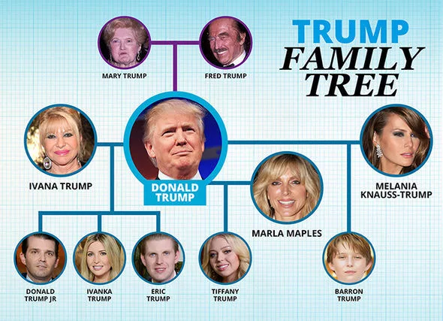

## Ответы

1. Fred is Barron’s _______________.
2. Melania is Donald’s ____________.
3. Ivanka is Eric’s ________________.
4. Barron is Tiffany’s _____________.
5. Donald is Mary’s ______________.
6. Ivana is Fred’s ________________.
7. Fred is Mary’s ________________.
8. Eric is Fred’s _________________.
9. Tiffany is Donald’s ____________.
10. Mary is Ivanka’s ______________.

## Ответы

1. Fred is Barron’s granddad.
2. Melania is Donald’s wife.
3. Ivanka is Eric’s sister.
4. Barron is Tiffany’s stepbrother.
5. Donald is Mary’s son.
6. Ivana is Fred’s daughter-in-law.
7. Fred is Mary’s husband.
8. Eric is Fred’s grandson.
9. Tiffany is Donald’s daughter.
10. Mary is Ivanka’s grandmom.